

Course Code : CSE 404

Course Title : Software Engineering and ISD Laboratory

Project name : Bus ticket booking management system

Tutorial NO: 02

 **Submitted To**

**Dr. Mohammad Zahidur Rahman**

Professor

**Dr. Md. Humayun Kabir**

Professor

Department of Computer Science & Engineering Jahangirnagar University, Savar.

Group No : 02

Group members :

| **Sl** | Class Roll | Name |
| --- | --- | --- |
| 01 | 370 | Prokash Maitra |

**Activity diagram for Admin**

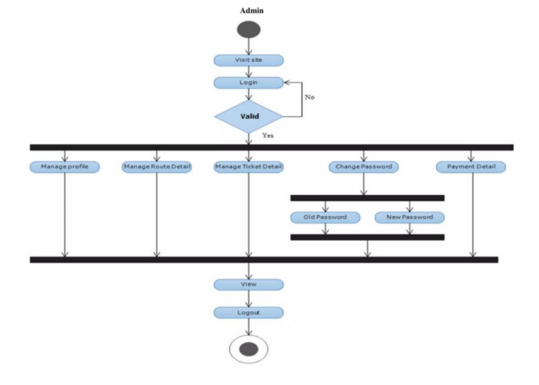

**Activity diagram for Customer**

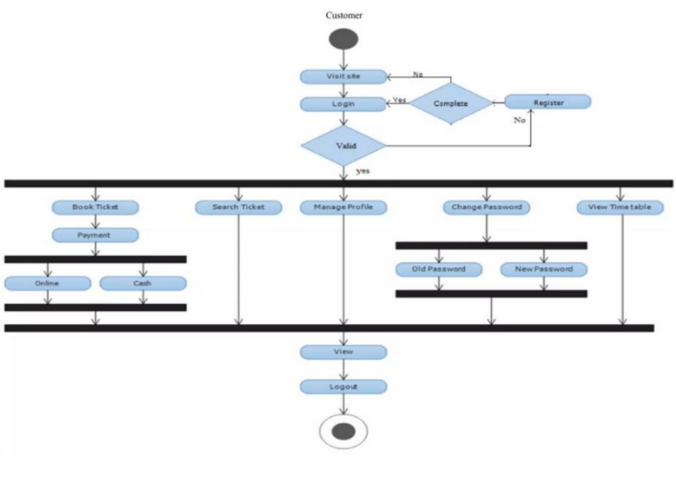

**Incremental model:**

**1st increment:**

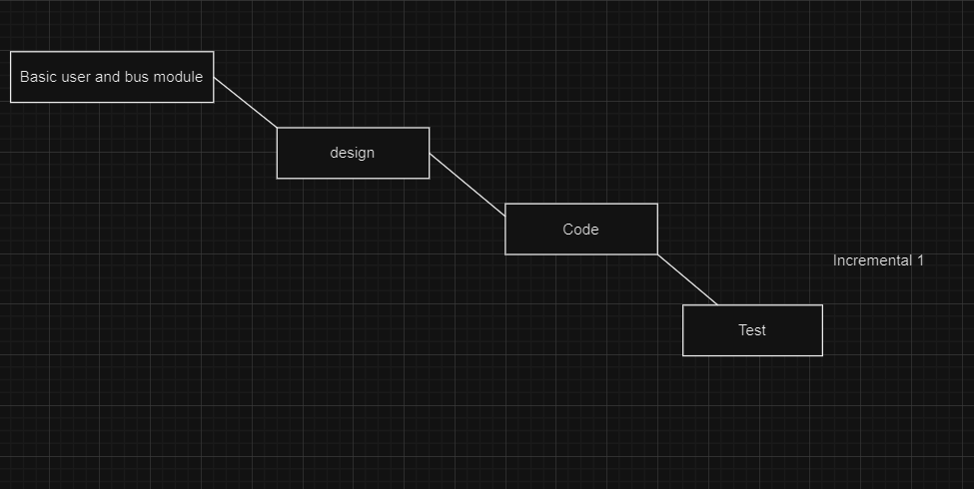

**2nd increment**

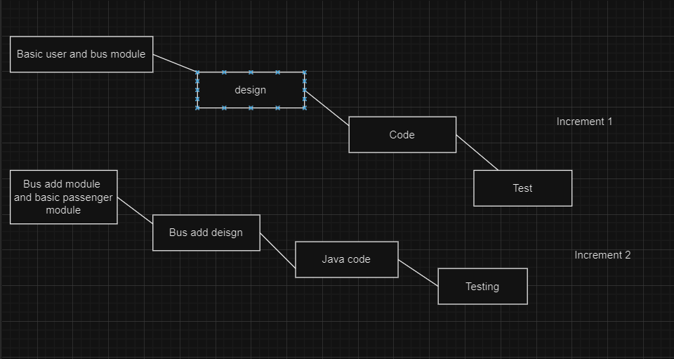

**3rd increment**

